## Case 1, Participant D

**Background**

Participant D is a male lecturer in his mid-thirties (25–34 age range) and a native Malayalam speaker. He uses generative AI tools daily and identifies as very proficient in their application. His tool set includes ChatGPT, Claude, and Grammarly, which he uses across a wide range of writing tasks—from idea generation and revision to composing full drafts and summarization. Participant D feels very comfortable integrating AI-generated content into his own writing and strongly believes that GenAI tools significantly enhance both the quality and process of writing. He emphasizes their utility in overcoming the “blank canvas” problem, organizing messy or unstructured ideas, and offering perspectives or critiques he might not have otherwise considered. His orientation toward GenAI is confident and constructive, viewing it as an active collaborator in shaping coherent, well-structured written work.

In the writing session, Participant D used Claude, ChatGPT, and Grammarly as his GenAI tools and Google Docs as his word processor within the side-by-side browser. He selected “Should classic children’s books be updated for today’s young readers?” as the easy topic and “Should certain animals have some of the same legal rights as people?” as the challenging one. For both, he responded to all provided prompts (i.e., reflection questions) by synthesising them into cohesive, unified essays.

**Main Claim**

Participant D’s experience demonstrates how GenAI tools enhance his writing by leveraging key affordances: Gather Information, Enhance Idea, Produce First Draft, Establish Common Ground, and enhance argument. GenAI saved him significant time in composing and structuring his ideas.

**Unpacking**

**Easy Topic**

Participant D began with the easy topic: *“Should classic children’s books be updated for today’s young readers?”* After reviewing the background information provided, he opened Claude and asked for examples of books that had been updated to reflect modern sensibilities. He also requested that the output be formatted as a table (see Fig. 1). [**Gather Information**] [**Steer Output**]

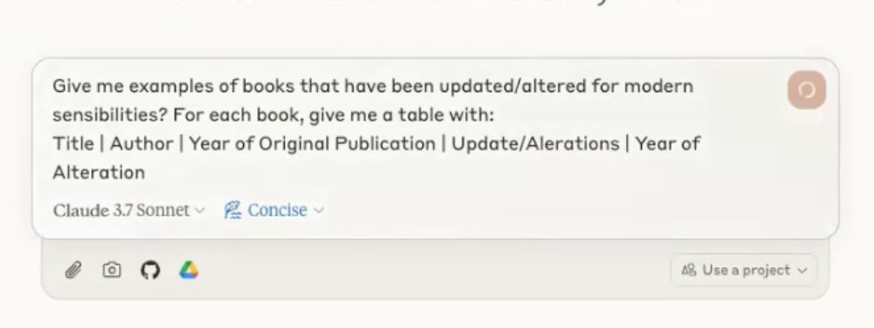

Fig. 1

After reviewing the generated content, he asked the GenAI to specify the passages that had been changed in each book, along with their contextual explanations (see Fig. 2). [**Steer Output**]

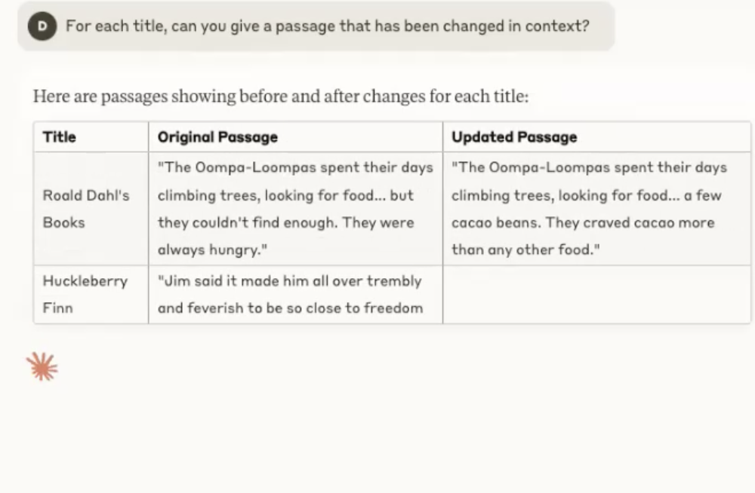

Fig. 2

Next, he copied and pasted the entire background information into the prompt and asked GenAI to generate bullet-pointed arguments in response to the reflection question on whether posthumous edits are necessary or a form of censorship (see Fig. 3). [**Establish Common Ground**][**Steer Output**]

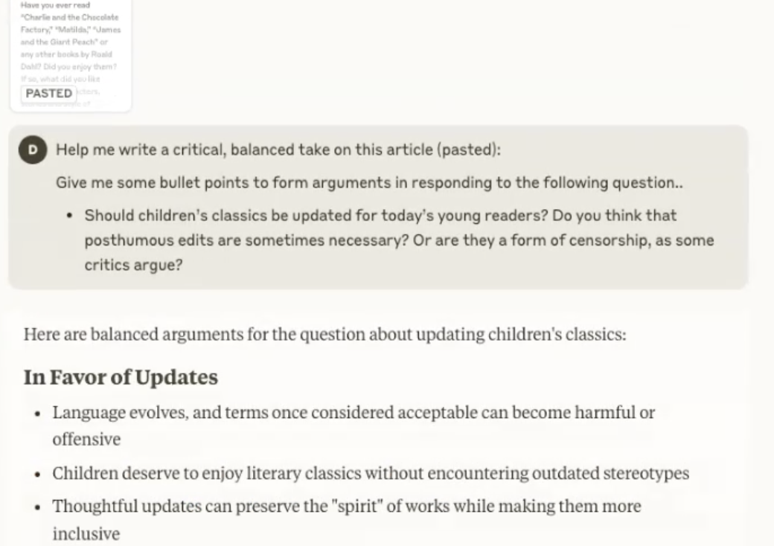

Fig. 3

After reviewing the output, he changed the **built-in** editing style from “Concise” to “Formal” and instructed GenAI to act as a journalist, asking it to write an article using his ideas (see GIF. 1). [**Produce First Draft**] He explained, *“So I give it my opinion, and then I use that to get it to generate the actual text. My thinking was, if I give it my reasoning and my opinion, then obviously it can add padding to it—or add less to it. I can give it a one-word bullet point, and it can turn that into a three-sentence paragraph, and also place it in the right part of the text to improve the argument’s flow.”*



GIF. 1

While drafting a point about harmful stereotypes, he turned to ChatGPT, rather than Claude, to ask about the book *To Kill a Mockingbird*. He described ChatGPT as “more like a throwaway, disposable AI,” suggesting he used it for quick, low-stakes queries. He added, *“I use ChatGPT a lot more now, even with that caveat, because of its internet search functionality. It will actually give you a link to people’s blogs where someone might have said it, and then I can click through and read the blogs. Claude doesn’t do that yet.”*After receiving the output from ChatGPT, he incorporated it into his initial prompt in Claude (see GIF. 2). [**Gather Information**]



GIF. 2

After obtaining the outputs, he asked Claude to remove any fabricated references. He explained, *“Yeah, I read through it and was happy with it. But before I copied it, I noticed the first version included made-up references. So I said, ‘Okay, can you output that again with actual references this time?’ That gave me more confidence. To be honest, I’m quite utilitarian about it—I just want it to work.”*. Finally, he copied the output into his Google Doc.

**Challenging Topic**

In a new chat, he moved on to the challenging topic: *“Should certain animals have some of the same legal rights as people?”* After reviewing the provided arguments, he began Googling information about key figures and books related to the topic (GIF. 3). He explained: *“I was really interested, but I didn’t know much about the debate. That article was the first time I came across someone arguing for giving animals legal personhood, which was completely new to me. So I started Googling and looking through media sources to understand it better. Once I saw it was inspired by Peter Singer, I recognised the usual critiques of his utilitarianism. Then I found a couple of critics pointing out that the argument relied on weak assumptions. That got me more curious, and I ended up reading seven or eight pages of the book review. It was long—but a really interesting debate.”*



GIF. 3

After switching back to Claude, he asked it to answer the reflection questions using the pasted gathered information from previous searching as context. He also requested that Claude use Poisner’s article—a key piece in the field—as the basis for critique. To support this, he used the **built-in** file upload function to attach the book he had found by Poisner. In the same prompt, he included his own viewpoints on the topic (see GIF. 4). He continued: *“Over the past year and a half, I’ve realised Claude is better for writing-related or creative tasks. It also helps that it has a larger context window. I can upload a lot more PDFs—like 10 or 15—and the responses feel much more in tune with what I’m trying to do.”* [**Upload File**; **Establish Common ground; Produce First Draft; Enhance Idea**]



GIF. 4

After receiving the generated article, he copied it into Google Docs and began final editing, including rewording and adding transition words. He also used Grammarly to assist with the editing process (See GIF. 5). [**Proofread**]



GIF. 5

Beyond the writing sessions, Participant D discussed how GenAI supports his work in research and teaching. He emphasised the value of large context windows, explaining how he uses GenAI to process and extract key information from dense documents. *“If it's a really big document—like a grant application with a huge list of guidelines—I upload it and just do a Q&A rather than reading it cover to cover,”* he said. [**Establish Common Ground**, **Summarise**, **Gather Information**] When writing in a new or unfamiliar area, Participant D downloads multiple policy papers, uploads them to the tool, and asks for a tailored relevance statement. *“The bigger context window has made it so much more powerful for the kind of writing I do. It’s rarely simple stuff—it needs lots of background for the answer to be useful.”* He also described creating folders of reference material or example documents—like medical exemption letters—to help the tool generate project-specific drafts. *“Sometimes I just make a big text file, give it a specific name, and upload it with my project details,”* he added.

## 

## Case 2, Participant A

**Background:**

Participant A is a male third-year PhD student in Information Technology, aged 25–34, and a native Bengali speaker. He uses generative AI tools weekly and has experience with platforms such as ChatGPT, Claude, and Grammarly. He identifies his proficiency with these tools as neutral and he feels somewhat comfortable integrating AI-generated content into his writing. Participant A primarily uses GenAI for generating ideas, revising grammar and structure, and summarising content. He acknowledges benefits such as efficiency, improved formatting, and idea generation, yet expresses critical concerns. While he agrees that AI tools can enhance the quality of written output, he questions their impact on human creativity, cognitive engagement, and the writing process itself. Participant A is particularly wary of the potential for bias introduced by AI and the risk of users becoming overly reliant on machine-generated suggestions.

In the writing session, Participant A used ChatGPT as his GenAI tool and Google Docs as his word processor within the same browser. He selected “Should all children under 16 be barred from social media?” as the easy topic and “Is Single-Sex Education Still Useful?” as the challenging one. For both, he responded to all provided prompts (i.e., reflection questions) by synthesising them into cohesive, unified essays.

**Main Claim**

Participant A’s experience demonstrates how GenAI tools enhance his writing by leveraging key affordances: Gather Information, Enhance Clarity and Tone, Enhance Idea, Refine Iteratively, Produce First Draft, and Enhance argument. GenAI not only lowered writing barriers and saved him significant time in composing and structuring his ideas, but also created a safe space that encouraged him to express his thoughts freely—making the writing process both more efficient and more approachable, and ultimately boosting his confidence in writing.

**Unpacking**

**Easy Topic**

Participant A began with the **Easy** topic: “*Should all children under 16 be barred from social media?*”. After skimming the background information, he turned first to Google, pasting this central question into the search bar. He explained: “*I wanted to know what’s actually going on… I have this belief that ChatGPT might not always give 100% accurate answers when it comes to facts. So I started with Google*”. There, he discovered recent legislation in Australia and then he returned to ChatGPT with the same query and added a follow-up: “*What laws have been proposed and implemented? Make it to the point, not too broad.*”. From this exchange, he learned that the issue wasn’t simply about restricting users, but about urging tech companies to redesign their platforms. “*That was the thing,*” he recalled. *“I found Australia [passing new legislation] from Google… but I used ChatGPT to find out what other countries are doing. ChatGPT is quicker—in my experience, it’s faster at generating this kind of knowledge. If I’d done it with Google, I’d have had to search for many countries individually—like, does the US implement this?*” [**Gather Information**]. He added “*GenAI is quicker in terms of summarising this information.*” [**Summarise**] [**Steer Output**]. (See Fig. 1)

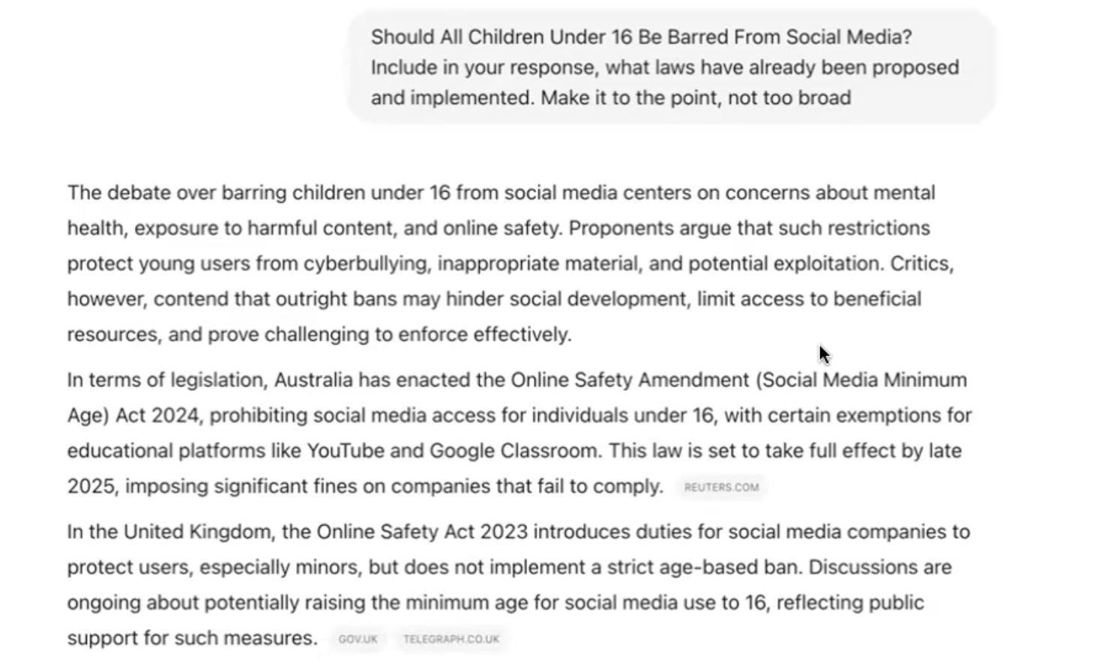

Fig. 1

After reviewing ChatGPT’s initial response, Participant A prompted it to summarise the response in no more than three paragraphs and to condense the discussion toward forming a personal argument **[Summarise] [Produce First Draft]**. After receiving the summarised content, Participant A found that the AI’s position conflicted with his own. “*For this answer, my initial reaction was negative—in terms of social media use. I was slightly aligned with the Australian government’s stance that, yes, it could be banned. It might actually be a good plan,*” he explained. However, ChatGPT offered a contrasting view, arguing that such a ban would be neither practical nor equitable. “*That’s fine,*” he noted. “*I didn’t disregard ChatGPT’s response, but I started giving prompts based on why I think social media should be banned—why I agree with this proposal [banning social media].*” This shift marked the point where Participant A began to challenge the GenAI and express his own thoughts more deliberately. “*That was part of my thought-building process—and also about including my argument into the writing.*” To do this, he introduced prompts that considered alternative contexts, asking ChatGPT to factor in varying socioeconomic backgrounds, cultures, races, and economic conditions (Fig. 2). “*I tried to be as detailed as possible,*” he added, framing this moment as an active negotiation with the AI. **[Enhance Argument]**

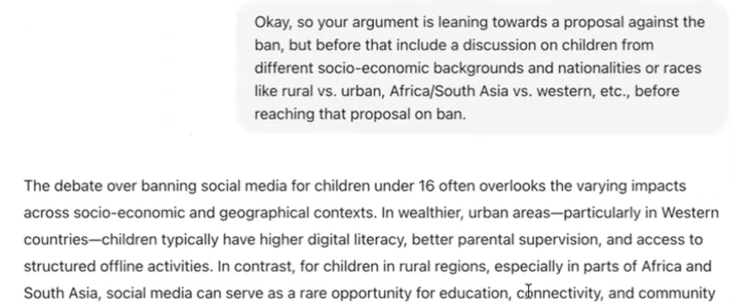

Fig. 2

After prompting ChatGPT to account for socio-economic and cultural differences, Participant A observed a convergence between his position and the AI’s from the responses, describing the result as “more balanced.” He provided feedback through a prompt to ChatGPT—“*sounds more balanced”* (See Vid. 4)—to affirm the direction of the discussion. “*These are the things I was thinking about,*” he commented. *“I see that sounds more balanced.*” [**Enhance Argument**] He continued, “*It is also good and quicker to converge on a solution. If there were no GenAI and it was only me—when I want to merge these two ideas to make a coherent conclusion—I, as an individual, would take much longer than ChatGPT. It’s faster, quicker, and reasonably efficient*” [Productivity and Efficiency Enhancement]. In the same prompt, he reminded ChatGPT to stay aligned with the original scope of the topic: children under 16. He issued a corrective prompt to steer the AI’s focus back, ensuring it didn’t generalise the discussion beyond that age group. “*I wanted to remind ChatGPT*,” he explained. “*They were heading in the right direction—they were doing well—but they just needed to keep the age context in mind so they didn’t change their response completely. That’s why I wrote that*” [**Steer Output**].

​​Participant A asked ChatGPT to elaborate on its reasoning behind specific positions—specifically why it believed banning was "neither practical nor equitable" and why recreational use might be considered beneficial despite potential cultural concerns. He explained his motivation: *The reason I wanted the further explanation is so when I see the explanation, I might miss that point. That might not be in my mind. So when I get it from ChatGPT, I might fine tune it to make the conclusion. So that's what I do in the last step.*” [**Expand**] [**Enhance Idea**]. After that, Participant A prompted ChatGPT on implications for platform developers or owners and asked it to summarise into one paragraph. [**Enhance Idea**] [**Summarise**].

After receiving these outputs, Participant A used a strategy—selectively choosing paragraphs from all previous versions of writing (i.e., from various AI responses) to construct his essay. (See GIF. 1) [**Produce First Draft**][**Revisit Chat History**] He described his process: “*So once I have got this, let's say four, five, or ten different versions of writing, okay, then what I do is I copy paste some parts. So let's say the first paragraph of this part, second paragraph of the other part, third paragraph,*” He then edited these excerpts—deleting or rewriting sentences and rephrasing as needed—to ensure coherence and logical flow. “*It might look really disconnected when you copy-paste from different responses, even though they’re all from the same question,*” he noted. “*The story doesn’t follow. For example, in the first paragraph I might be talking about countries, and suddenly in the second I jump to low-income regions. That jump needs to be justified or rearranged. And then sometimes I delete some sentences or rewrite some sentences, some words.*”



GIF. 1

**Challenging Topic**

After completing the first writing task, Participant A moved on to the more **challenging** topic: “*Is Single-Sex Education Still Useful?*” After skimming the background information and reflection questions, he remained within the same ChatGPT thread and entered the new writing topic along with all reflection questions provided. He then asked ChatGPT to generate a response using a similar structure and approach to the previous (simpler) topic (See GIF. 2). [**Establish Common Ground**]



GIF. 2

He explained, “*Because the conversation is already going on… I wanted to let ChatGPT know: just use a similar approach to write on a different topic.*” He also noted a key difference: “*Unlike the previous topic, I don’t have enough experience with this one, so I entered all the sub-prompts [to ChatGPT]*” [**Establish Common Ground**] [**Enhance Idea**] [**Produce First Draft**].

After receiving the response, and similar to his approach in the previous writing topic, Participant A began shaping the tone and direction of the AI-generated essay through iterative refinement [**Refine Iteratively**] [**Enhance Clarity and Tone**]. He started by asking ChatGPT to elaborate on specific points and adjust its tone [**Expand**]. Next, he identified language that appeared biased—such as labelling one society “progressive” while leaving the other unlabelled—and prompted the model for clarification and revision [**Enhance Clarity and Tone**]. He then asked ChatGPT to explore how single-sex education could function effectively in both societies that recognise gender diversity and those that do not. Finally, Participant A guided the model to address whether single-sex schools could accommodate transgender students across different cultural contexts, prompting a more nuanced and inclusive consideration of the topic [**Steer Output**]. Particularly, after the final interaction, Participant A returned to his earlier prompt about single-sex schools and revised it directly within the same input field (**built-in**)—expanding the scope to include curriculum design, gender roles, and identity. Instead of entering a new follow-up, he modified the existing question before regenerating the response (See GIF. 3) [**Edit Prompt**]. He explained: “*That [initial response] was my first version, yeah. Then this [regenerated] response was completely different—ChatGPT rewrote it and completely forgot what it had written before, which is actually what I wanted. I didn’t want to follow up on that first version.*” Finally, similar to the process during the first writing topic, Participant A selectively chose paragraphs from all of the responses to assemble his essay, with rephrasing, adding connecting phrases, or rewording where needed. [**Revisit Chat History**]



GIF. 3

Beyond the task-specific observations, Participant A repeatedly emphasised how generative AI supports his daily writing by saving time. “*The other thing, which I’ve mentioned several times,” he noted, “is getting enough—and diverse—information in a short amount of time. So saving time is an obvious one. Always time, time.*”. He also described GenAI as creating a comfortable and safe space for writing, supported by two key factors. First was the private, conversational format: *“I like the form of chat. It’s like chatting. I think it’s inclusive for many types of people—introverts or extroverts. It gives a feeling of safety or security*”. Second, GenAI lowered the barrier to writing by handling grammar and stylistic refinement, which in turn boosted his confidence. “*You can write literally whatever is in your mind,*” he explained. “*That gives you freedom and more courage—to just write your first draft, then give it to ChatGPT. It can rephrase it into a more academic tone, more formal, richer English… ChatGPT will fix everything else*” [**Enhance Clarity and Tone**].

**Packing**

Participant A’s experience illustrates how GenAI tools support his writing through key affordances: Gather Information, productivity and efficiency enhancement, idea enhancement, iterative refinement, and argument enhancement. He used GenAI to gather and synthesise diverse information, establish writing foundations, and structure balanced arguments. Across both writing tasks, he iteratively refined AI outputs through prompts—adjusting tone, challenging bias, and embedding his own viewpoints—to co-construct more balanced positions.

He highlighted GenAI’s value in saving time, offering a private and low-pressure writing environment, and boosting confidence by lowering the barrier to expressing early ideas. Ultimately, Participant A used GenAI not just as a writing assistant, but as a dynamic collaborator in both idea development and composition.

## Case 3, Participant F

**Background:**

Participant F is a female lecturer in Engineering, aged 35–44, and a native Persian speaker. She uses generative AI tools daily, primarily ChatGPT and Copilot, and describes herself as proficient with GenAI tools. Participant F applies these tools regularly in her writing for tasks such as editing or revising text, summarising content, and other uses like coding, image generation, and preparing LaTeX slides. She feels very comfortable integrating GenAI outputs into her own work and strongly believes these tools improve both the quality and the process of her writing. Participant F particularly values GenAI’s ability to articulate complex ideas more effectively, simplify technical content, and help structure her writing with greater clarity and coherence. For her, GenAI not only streamlines the writing process but also enhances communication, especially when translating technical ideas for a broader audience.

In the writing session, Participant F used ChatGPT as her GenAI tool and Google Docs as her word processor. He selected “Are A.I.-Generated Pictures Art?” as the easy topic and “Should Certain Animals Have Some of the Same Legal Rights As People?” as the challenging one. For both, she responded to all provided prompts by synthesising them into cohesive, unified essays.

**Main Claim**

Participant F’s experience demonstrates how GenAI tools support her writing through key affordances: Establish Common Ground, Enhance Idea, Enhance Argument, Enhance Clarity and Tone, and Gather Information. She used GenAI not only to generate and organise ideas, but also to iteratively revise and polish her writing—streamlining transitions, clarifying meaning, and improving grammar and structure. These affordances collectively reduced the language barrier, accelerated her workflow, and enabled her to express complex thoughts more effectively.

**Unpacking**

**Easy Topic**

Participant F began with the **simpler** topic: “Are A.I.-Generated Pictures Art?” To start, she pasted the background information containing basic AI-generated art introduction and people’s opinion towards AI-generated into ChatGPT and asked it to summarise the content. She explained, “*I usually don't have time to read, so I try to summarise the text first… then I don't need to read the whole thing. I can just get the idea quickly*” [**Establish Common Ground**] [**Summarise**]. After skimming the summary, she moved on to idea generation—asking GenAI to brainstorm while simultaneously contributing her own initial thoughts. *“I try to just give my ideas in bullet points or something,*” she noted, “*and I also brainstorm some ideas from them [GenAI]*” (See Fig. 1) [**Enhance Idea**]

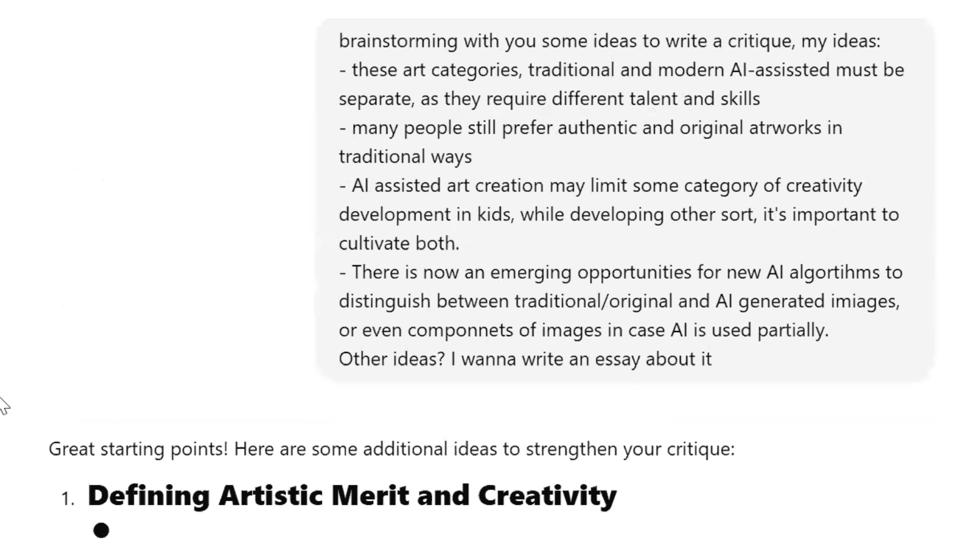

Fig. 1

After that, Participant F asked ChatGPT to merge her bullet-pointed ideas with the AI-generated ones and craft a cohesive essay. The resulting essay included multiple clearly defined sections with explicit titles, such as *“AI Art and Cultural Authenticity”*. “*I try to just give my ideas in bullet points*,” she explained, “*and I also brainstorm some ideas from them so that ChatGPT can merge them or incorporate them*” [**Enhance Idea**].

After pasting the AI-generated essay into her word processor, Participant F began revising it section by section. For each part, she read through the content and returned to ChatGPT with the original text alongside specific instructions. Overall, her revisions followed three main strategies–each of which involved further interaction with GenAI– adding factual details to strengthen the section’s argument, incorporating her own ideas and opinions, and improving logical connections between paragraphs [**Enhance Argument**] [**Enhance Idea**] [**Enhance Clarity and Tone**]. She explained “*Then I started to read every section and see what could be added, what could be merged, for example.*” [**Refine Iteratively**]

In the first strategy—adding factual support—her prompts often began with “add the fact that...” followed by a targeted point she wanted to emphasise. These additions included statements such as the need to certify human-made artworks, the observation that AI-generated art may be visually appealing at first glance but fails to create deeper emotional connections, and the argument that AI-assisted art should be introduced to children only after they develop foundational artistic skills (e.g., GIF. 1) [**Enhance Argument**].



GIF. 1

The second strategy—incorporating her own ideas and opinions—involved prompting ChatGPT to expand on points that reflected her personal stance or perspective. For example, she asked to consider that human-made art may become more valuable and expensive due to its originality, and would likely maintain a dedicated market. She also proposed that AI algorithms could be trained on culturally specific artworks to better reflect regional traditions, while noting that those interested in cultural arts would still prefer human-made creations. In another case, she raised concerns about AI-generated art violating original reference rights and suggested the potential for AI tools to detect sources and suggest citations or major similarities. Occasionally, she followed up with additional instructions to revise the output further [**Steer Output**, **Enhance Idea**, **Iterative Refinement**]. (e.g., Fig. 2)

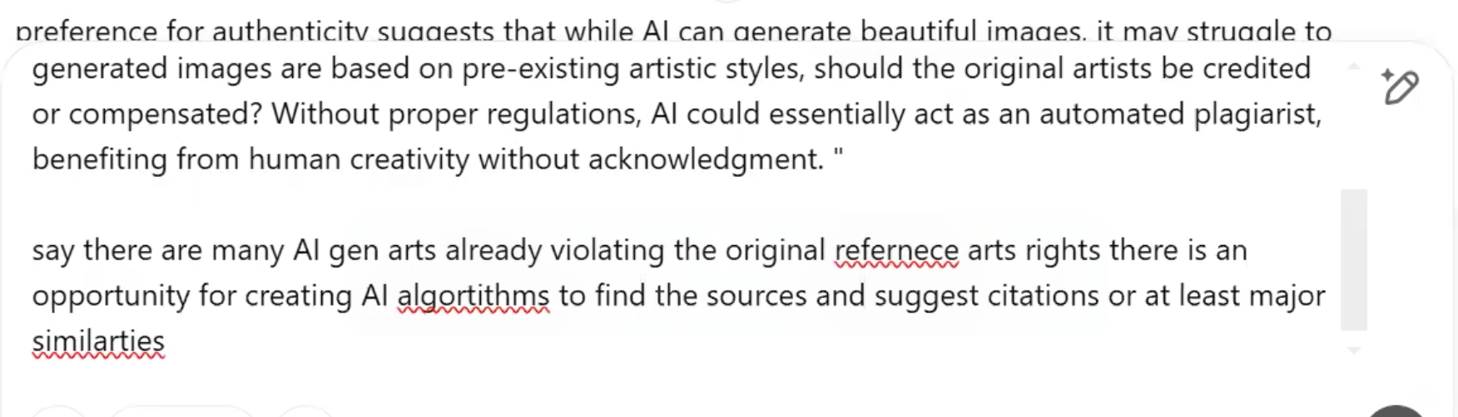

Fig. 2

The third strategy—improving logical connections between paragraphs—involved Participant F directing ChatGPT to strengthen transitions and overall coherence. In one instance, she asked the model to “echo the previous paragraph,” referring specifically to a section titled *“Separating AI-Generated and Traditional Art Categories,”* to ensure thematic continuity. In another case, after adding a paragraph herself, she prompted ChatGPT to “merge the previous and the new one better, more logically,” aiming to create smoother flow between ideas and reduce abrupt shifts in the narrative [**Enhance Clarity and Tone**]. (e.g., Fig. 3)

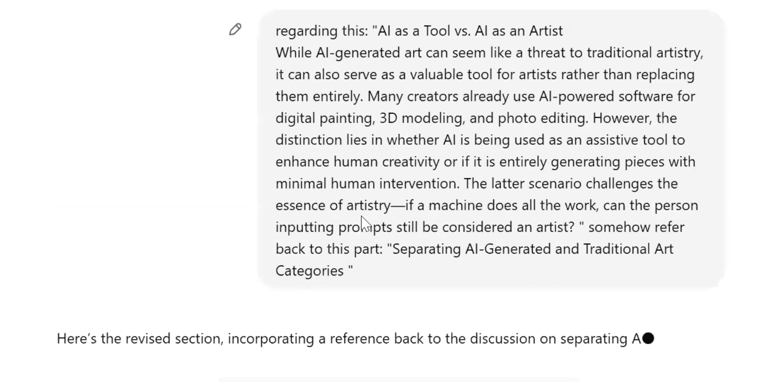

Fig. 3

**Challenging Topic**

Moving on to the **challenging** writing topic—*“Should Certain Animals Have Some of the Same Legal Rights As People?”*—Participant F chose to stay within the same conversation thread as the first writing task. She pasted the new background information and asked ChatGPT to summarise it (see Fig. 4). She explained, *“I just didn’t want to bother starting a new conversation, and it knows… when I’m saying I’m writing an essay, it knows what sort of essay I’m writing, so it does the same task but for a different topic. So I thought it makes sense. I just need to tell ChatGPT that this is a new topic but the same path*” [**Establish Common Ground**].

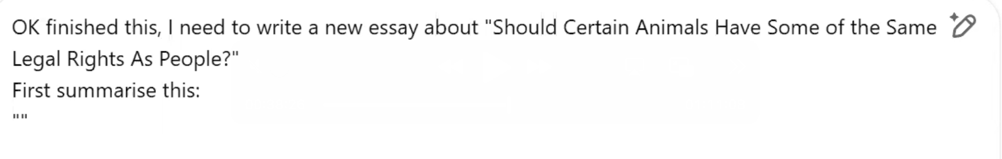

Fig. 4

As with the first topic, Participant F began by pasting the background information into ChatGPT and asking it to summarise the content [**Establish Common Ground**]. She then followed up with a question about whether the legal rights mentioned in the prompt existed in certain cultures (Fig. 5), using the tool to explore perspectives. Reflecting on this step, she noted, “With the second one, I probably had no idea at the beginning how to start, and I didn't have much background in how different cultures believe in animal rights.” [**Gather Information**].



Fig. 5

After skimming the synthesised search outcomes provided by ChatGPT, “*ChatGPT provided that [search outcome] was well done.*”, Participant F noted. Participant F began to express her own ideas and steer the direction of the essay. She suggested focusing on cultural elements as a foundation for respecting animal rights, rather than solely relying on legal frameworks. “So it was just a single idea of culture for me and then the rest was all ChatGPT helping”, she explained. [**Enhance Idea**]. (Fig. 6)



Fig. 6

After that, she edited her previous idea directly within the same input field by adding more instructions, rather than submitting a new prompt (**Built-in**). She explained, “Yeah, because it sometimes just misunderstands what I want, and it’s easier just to go back and edit that rather than asking something new—because then, when you ask a new question…” (GIF. 2). [**Edit Prompt**]



GIF. 2

Then, Participant F asked ChatGPT to provide references for a section of the essay that discussed cultural and religious perspectives. She explained, “From a new point of view of blending cultural background into this kind of topic… I asked about certain cultures. Yeah, I’m not quite sure how true it is, so I need to also ask for references and check the references” (Fig. 7). [**Gather Information**].

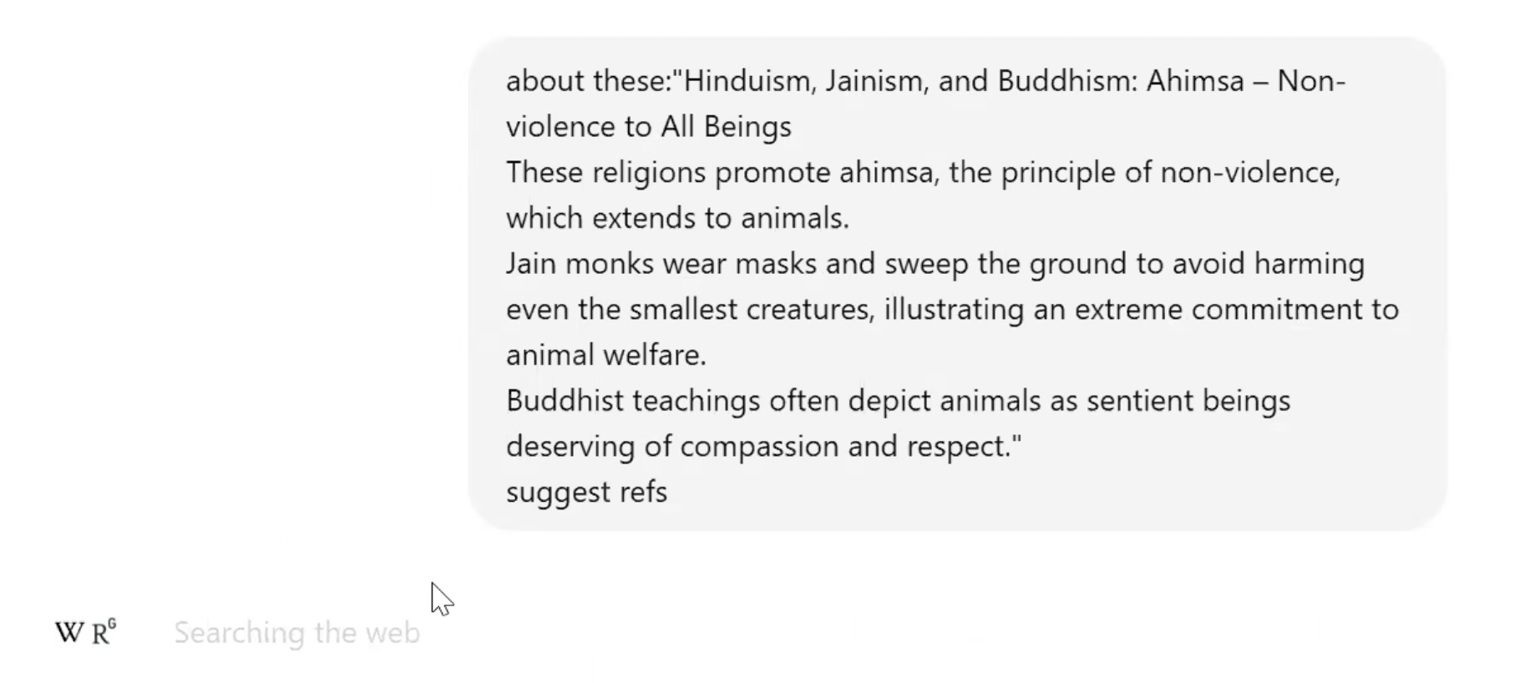

Fig. 7

After checking the search output, Participant F conducted a follow-up query focused on Indigenous Australian beliefs related to animals. She explained, “I just wanted to add one, like, Australian Indigenous belief as well—that’s why I asked.” After receiving a lengthy response, she then prompted ChatGPT to reformat it into a single bullet point for easier integration. “The answer was too long,” she recalled, “so I just wanted one bullet point and then copied that into the text—because I just realised there is no Australian Indigenous kind of example in there, yeah” [**Gather Information**] [**Steer Output**]. (GIF. 3)



GIF. 3

Beyond the writing sessions, Participant F reflected on how GenAI made her writing process more efficient by streamlining the editing stage. She explained, “*It [writing without ChatGPT] took me a long time to be able to write my ideas—from my head to paper. I used to just write my ideas in bullet points, but then the process of writing paragraphs for each bullet point was very difficult—because English is not my first language. It was very difficult when I was a PhD student, I would say.*” She highlighted that ChatGPT now plays a key role as a writing assistant, especially in proofreading, grammar correction, and structural adjustment. “I just write it and then I ask it to edit and connect the paragraphs,” she added. “A good editor”[**Enhance Clarity and Tone**].

**Packing**

Participant F’s writing sessions highlight the several affordances of GenAI across both writing tasks. She relied on the tool for summarising background texts, brainstorming, and merging ideas—both her own and the AI’s—into cohesive essays. Her revision process was particularly active: she worked section by section, prompting ChatGPT with targeted instructions to add specific facts, incorporate her perspectives, or strengthen transitions. She also edited prompts directly within the input field to fine-tune responses, and frequently asked follow-up questions to validate information, especially when addressing culturally sensitive or unfamiliar content.

Beyond the sessions, Participant F reflected on how GenAI has made her writing more efficient and less cognitively demanding. Particularly valuable to her was the tool’s ability to transform rough ideas or bullet points into well-structured paragraphs, significantly lowering the language barrier. By supporting grammar correction, paragraph connection, and stylistic refinement, GenAI enabled her to focus more on content and less on form—making the writing process both faster and more approachable.

## Case 4, Participant L

**Background**:

Participant L is a male postgraduate (PhD) student in Information Technology, aged between 25–34, and a non-native English speaker. He reported using generative AI tools—primarily ChatGPT and Grammarly—on a daily basis for writing tasks. He considers himself proficient in using such tools and is somewhat comfortable integrating their outputs into his own writing. His main uses include generating ideas and editing or revising text, and he strongly believes that GenAI tools improve both his writing quality and process. Participant L highlighted that these tools help him easily access revision suggestions, synonyms, and sentence structures, ultimately enhancing the richness of vocabulary, grammatical correctness, and cohesion in his writing.

Participant L used LobeChat (Fig.1), an open-source LLM chat platform integrating various AI models and tools, with GPT-4o-mini as his chosen model. For drafting and editing, he used Google Docs as his word processor. His two selected topics were “Are Self-Driving Vehicles the Wave of the Future?” (simple) and “Are AI-Generated Pictures Art?” (challenging). Instead of addressing prompts for each of the topics separately, Participant L opted for a holistic approach, crafting a comprehensive response that incorporated all prompts within a single piece.

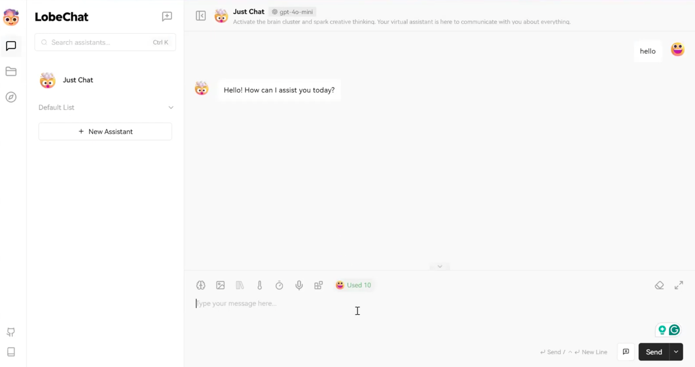

Fig.1 Chat interface that Participant L used in his writing

**Main Claim:** Participant L’s experience demonstrates how GenAI tools enhance his writing by leveraging key capabilities: Gather Information, Establish Common Ground, and Enhance Clarity and Tone to facilitate writing efficiency and improve his writing skills.

**Unpacking**

**Easy Topic**

Participant L began with the **simple** writing topic: “Are Self-Driving Vehicles the Wave of the Future?”, first expressing his viewpoint and drafting the introduction on his own in a Google Doc. When discussing the levels of automation, he consulted GenAI to quickly understand the classifications of autonomous driving [**Gather Information**]. (Fig. 2) He explained, “*For unfamiliar concepts, I can ask GenAI for a quick overview.*” After reviewing the response, he refined his draft by copying the definition directly from GenAI’s output into his draft.

To improve cohesion and clarity, he then asked GenAI to refine this section—pasting draft into LobeChat [**Enhance Clarity and Tone**]. After receiving the revised version, he further requested a better expression for a specific clause. He noted, “*If I’m not satisfied with the response, I can ask GenAI to generate multiple versions in my preferred format.*” [**Steer Output**] [**Refine iteratively**]. GenAI provided two alternative phrasings, and Participant L selected the second one, integrating it into his writing with minor edits, including adding transitions to ensure a smooth fit within his text.

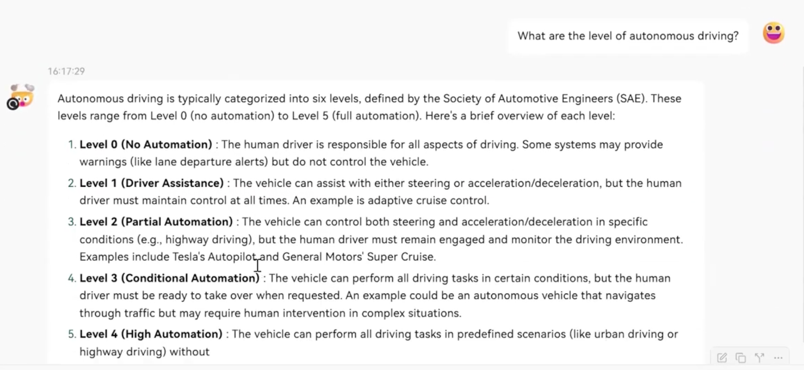

Fig 2. Asking question to GenAI

After the introduction, Participant L continued writing about concerns regarding current self-driving technology and future directions . Whenever discussing the classification of autonomous vehicles, he revisited his earlier GenAI response for a clearer understanding [**Revisit** **Chat History**]. After reviewing the information again, he specified the level of automation that the future vehicles should aim to achieve.

Once Participant L completed his initial draft, he sought feedback and improvements on refining his essay in terms of sentence structures, grammar by copying and pasting his first paragraph into GenAI [**Provide Feedback**]. He then repeated this process with the first two paragraphs. After receiving the response, he incorporated selected sentences from the response into his second paragraph to refine his original writing. He followed the same approach for the final paragraph. Reflecting on his process, he noted, “*I’m relatively familiar with the topic of self-driving vehicles and have read similar articles before. Compared to the second (challenging) topic, I mainly used GenAI to refine sentence structures and correct grammar, while the overall structure followed my own reasoning. For this first piece, my focus was primarily on grammar.*” [**Enhance Clarity and Tone**].



GIF. 1

**Challenging Topic**

For the **challenging** topic: “Are AI-Generated Pictures Art?”, Participant L started a new conversation with GenAI, first seeking background information on the definition of art. After reviewing the response, he followed up by asking about the key aspects that make a painting art. (Fig 3) He explained, “*I had no prior knowledge of this topic, so I used GenAI as a search engine to understand basic background information, definitions, and related concepts.”* [**Gather Information; Establish Common Ground**].



GIF. 2

When GenAI provided a bullet-pointed response, Participant L pasted it into his word processor and used it as a reference while drafting his essay. He clarified, “*After gathering the information, I used these background definitions as a foundation for writing. Since my essay focused on key points, I copied them directly for easy reference.*” Similar to the first topic, after he completed the initial draft, he copied and pasted it into GenAI, requesting improvements in cohesion and clarity [**Enhance Clarity and Tone**].

Beyond the writing session, Participant L highlighted how GenAI tools support his daily academic writing, particularly in enriching vocabulary and finding precise words. He explained, *"Vocabulary richness is especially important for those of us who don’t speak English as a first language."* He also noted the convenience of using GenAI for finding synonyms, saying, *"Before GPT, I had to rely on dedicated websites for synonyms, which required me to first think of a starting point and then search step by step. Now, GPT instantly provides concise definitions, explanations, and suggestions."* [**Enhance Clarity and Tone**].

Beyond refining language, Participant L found that GenAI also contributed to his writing skills. *"Its greatest value is in syntax and vocabulary. It doesn’t just correct my writing—it explains why, which helps improve my own writing ability."*

Another key affordance he mentioned was [**Enhance Clarity and Tone**], especially when writing response letters for academic reviews. *"When writing responses, this is particularly useful. Sometimes, without realising it, my tone might come across as too aggressive."* With GenAI, he felt more confident in his writing: *"Having GenAI as a safety net allows me to write more freely, knowing I can rely on it to refine my tone and structure."*

Compared to the period before GenAI, Participant L noted a significant improvement in his writing quality. *"The overall quality has improved dramatically. Before, I only had tools like Grammarly (before GenAI integrated), which were much more limited in what they could correct."*

**Packing:** Participant L’s experience demonstrates how GenAI tools enhance his writing through key capabilities: facilitating understanding of new knowledge and topic background information, enabling iterative interaction to refine outputs, and enhancing text in terms of vocabulary, grammar, tone, and structure. Beyond immediate text improvement, GenAI also supports his long-term writing development by broadening his vocabulary, refining his expression, and boosting his confidence in academic writing.

## Case 5, Participant B

**Background:**

Participant B is a female PhD student in Information Technology, aged between 35–44, and a native Sinhala speaker. She uses generative AI tools—primarily ChatGPT and Grammarly—weekly and describes herself as proficient. Her primary uses include editing or revising text and summarising content. While she feels only somewhat comfortable integrating AI outputs into her writing, she believes these tools improve both her writing quality and process. Participant B highlighted key benefits such as not needing to worry about grammar or spelling, gaining summarised views of ideas, and receiving an external perspective. She also noted that GenAI helps her smooth transitions and improves vocabulary access, even if she finds the quality of output occasionally uneven.

In Participant B’s writing process, she used ChatGPT as an assistant writing tool alongside Google Docs as her word processor. For the simple topic, she selected “*Should All Children Under 16 Be Barred from Social Media?*”, while for the challenging topic, she chose “*Should We All Go Cashless?*” Rather than responding to each prompt separately, she adopted a holistic approach, integrating all prompts into a single, cohesive response piece for each topic.

**Main Claim:** Participant B’s experience demonstrates how GenAI tools enhance her writing by leveraging key capabilities: Gather Information, Refine Iteratively, Enhance Clarity and Tone, and Provide Feedback.

**Unpacking**

**Easy Topic**

Participant B began with the **simple** writing topic by first assigning ChatGPT the role of an “*expert in research and essay writing.*” She then leveraged GenAI’s **built-in** web search functionality, pasting a link to the writing topic and asking it to read and summarise the background information of the article. (See Fig. 1) She explained, “*Whenever I want to search for something and get a summary, I just use the search function, enter the topic, and ask for a summary so I can go into the papers. I currently use the paid version, but even the standard version has the search function.*” [**Gather Information; Establish Common Ground**; **Summarise**; Role Assignment].

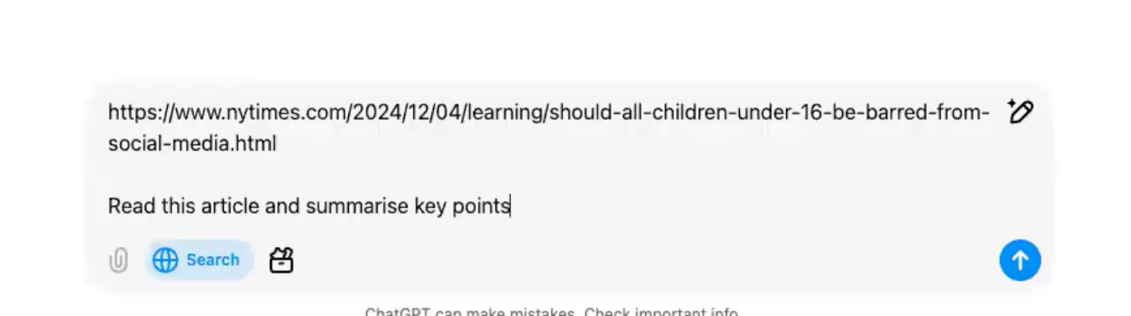

Fig. 1

After reviewing the response, she began writing the introduction. Once she completed this section, she copied and pasted it into GenAI, requesting additional sentences to expand on the broad pros and cons of social media [**Expand**]. She also specified that the additions should be for the introduction section [**Establish Common Ground**].

After receiving the response, she combined the original writing with GenAI’s output and prompted it to assess the cohesiveness of the revised version. Based on the comments and suggested improvements, she replaced her original introduction with the refined version. Reflecting on her process, she noted, *“The first topic is about banning social media. It’s something I’m comfortable discussing and already know a little about. I reviewed the summary, drafted my essay, and then asked GenAI to polish my essay*.”, she added more information regarding polish, “*I think polishes it comes into a place that it's very crisp, easy to understand, and then, like the punctuations, the choice of words are like very good, like I feel like personally my vocabulary, is limited sometimes the way that i'm using.*” [**Enhance Clarity and Tone**]

After completing the introduction, Participant B moved on to writing about the negative aspects of social media, frequently referring to the GenAI’s arguments as a guide. (See GIF. 1)Occasionally, she incorporated claims from the summary, modifying them to better fit her writing. [**Enhance Idea**]



GIF. 1

Notably, when providing an example of harmful content on social media, she mentioned a video game but left its name as a placeholder, *“<add the name>.”* She explained, *“I knew the example, but I couldn’t remember the name of the game. So I just put it in <>, which is something I usually do whenever I want to add details later.”* [**Steer Output**]

Once she completed the paragraph, she pasted it into GenAI, requesting proofreading, language refinement, and the insertion of the missing game name.[**Proofread**] [**Enhance Clarity and Tone**] [**Steer Output**] (See Fig. 2) After reviewing the polished version, she replaced her original paragraph with the refined one. She followed this same process for the next two paragraphs, iterating between drafting, prompting for refinement, and incorporating GenAI’s revisions into her final piece.

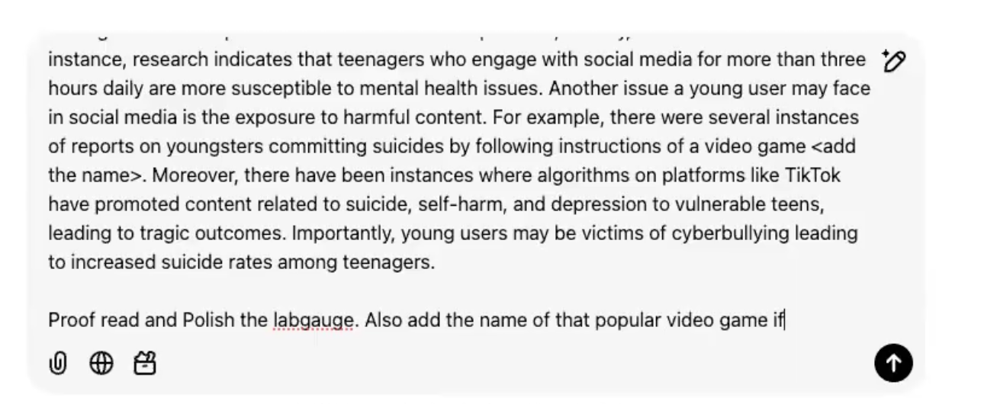

Fig 2

After completing her initial draft, Participant B copied and pasted the entire piece into GenAI, requesting proofreading and language refinement [**Proofread**] [**Enhance Clarity and tone**]. Upon receiving the revised version, she found the closing paragraph too long and prompted GenAI to condense it into just 2–3 sentences [**Summarise**]. Once satisfied with the refined version, she replaced her original conclusion with the revised one.

**Challenging Topic**

When moving to the **challenging** topic, Participant B started a new conversation with GenAI, maintaining a separate chat for each task. She explained, *“Whenever I have multiple tasks, I maintain a separate chat for each (to create a new context).”* [**Establish Common Ground**].

She followed a similar interaction pattern as with the simple topic—assigning GenAI a role as expert in essay and using the **built-in** web search function to summarise relevant writing materials. [**Summarise**] [**Establish Common Ground**] However, this time, she also asked GenAI to propose an essay structure [**Create Outline**]. She explained, *“For cashless payments, I’m already using them, but I don’t know much about the broader topic. That’s why I asked for a summary of key points and an essay structure.”*

Next, she requested GenAI to generate an introductory paragraph. [**Produce First Draft**] After reviewing the output, she started to write this paragraph on her own. However, after writing the first sentence, she deleted it. She explained *“The initial paragraph from GenAI didn’t sound like my writing—it was too advanced. So, I wrote the first sentence, but I knew I wasn’t there yet. That’s why I went back and deleted it.”*

Participant B decided to use the sentences from the GenAI output. She extracted two sentences from the GenAI-generated text and added transitions to make them fit her writing. She described the process as similar to academic work: *“I copied the sentences from GenAI, and it felt more like assembling ideas in a college assignment.”* [**Steer Output**]

Once she completed her introduction, she copied and pasted it into GenAI, requesting language refinement. She explained, *“I take pieces from what is written, assemble them into a paragraph, and then ask GenAI to polish it.”* [**Enhance Clarity and Tone**].

Participant B then moved on to writing a new paragraph detailing the benefits of going cashless, using the GenAI-generated summary as a reference. Specifically, she copied one point of view from GenAI, marking them with *<>* as placeholders for later revision. After completing the paragraph, she prompted GenAI to polish the language and specifically requested it to rewrite the copied sentences to better match her writing style. (See Fig. 3) She explained, *“It actually helps to rephrase and rewrite sentences, and I felt the rewriting was accurate.”* [**Enhance Clarity and Tone**]. Once satisfied with the refined version, she replaced her original paragraph with the improved one.

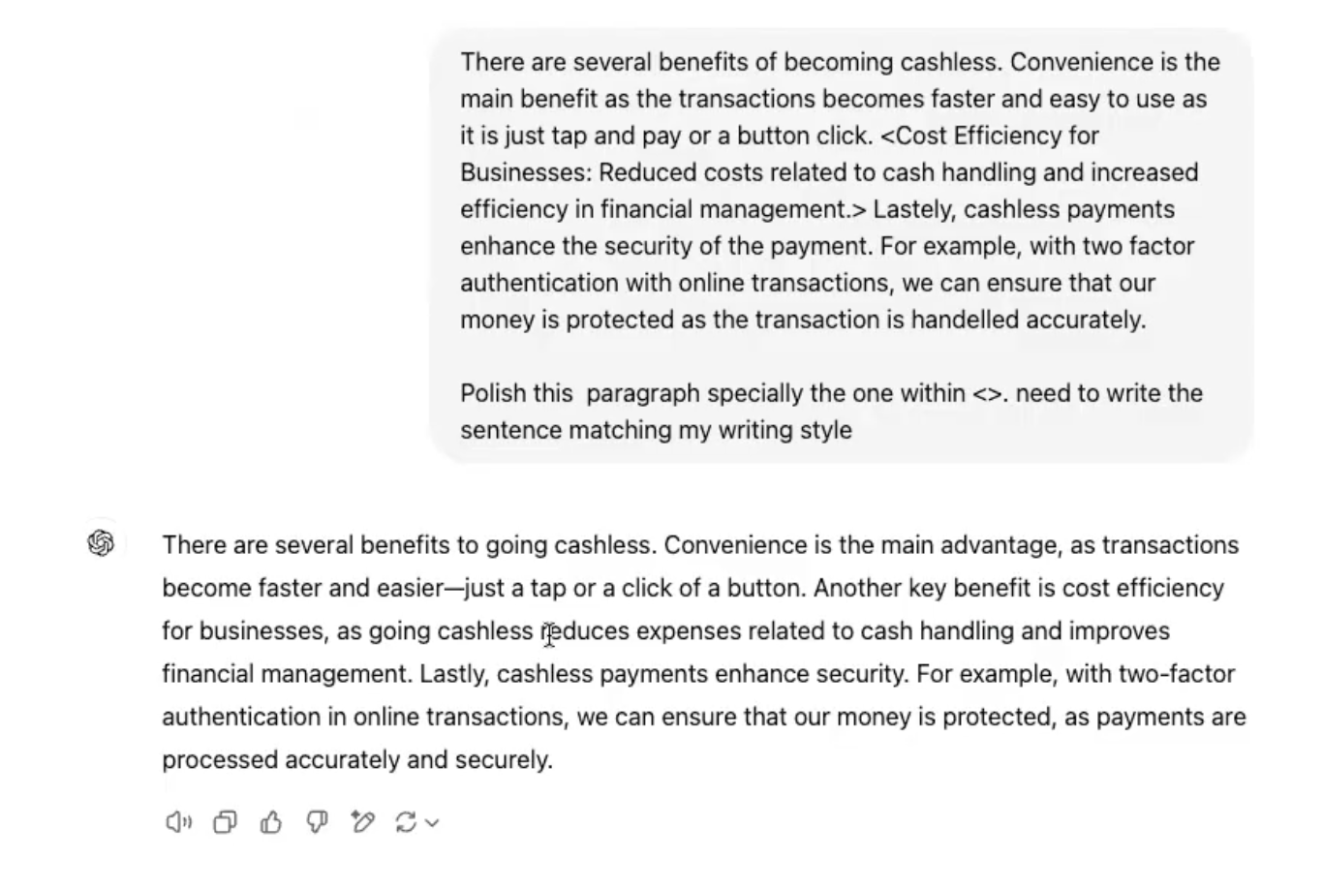

Fig. 3

For the paragraph on the challenges of going cashless, Participant B copied the claims and supporting points from the summary in the prompt area and instructed GenAI to compose the paragraph following the same pattern as her earlier benefits section (see Fig. 4). She explained, *“I looked at the benefits, wrote that section myself, then for the challenges, I directly told GenAI, I wrote the benefits—now write the challenges in a similar way.’”* [**Establish Common Ground**]

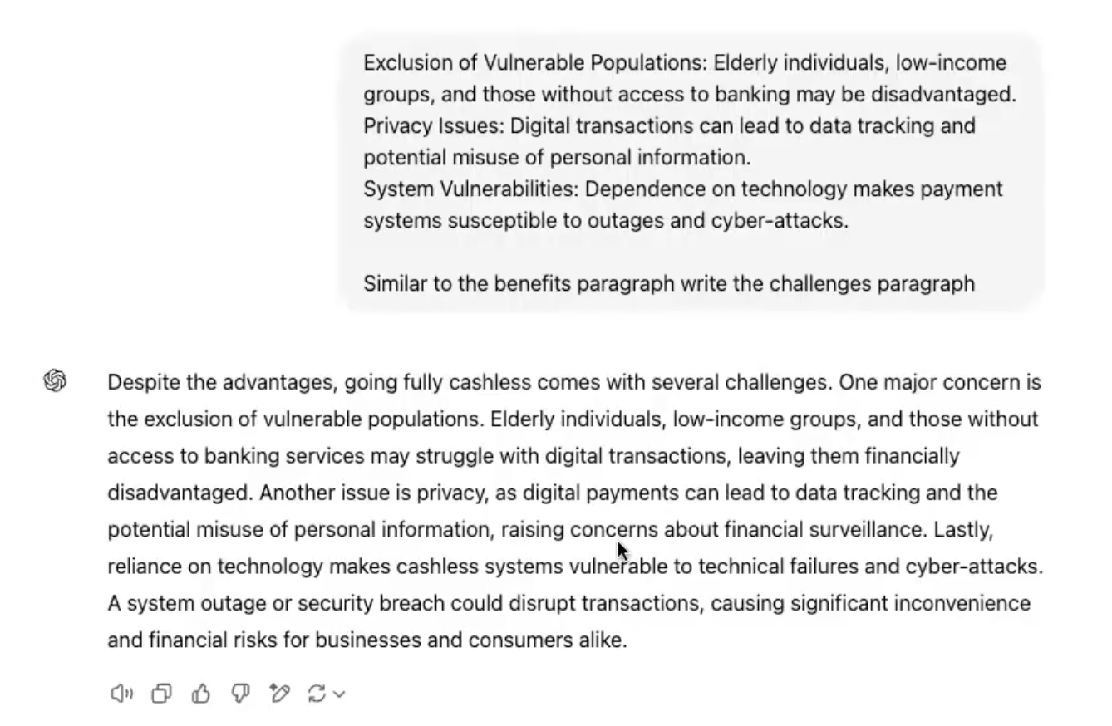

Fig. 4

Next, she asked GenAI to provide an example from the summary to support both the benefits and challenges sections. Additionally, she requested a reference for one of the examples in the challenges paragraph. She explained, *“I just copied that sentence and asked, ‘Show me the reference for it,’ and it came from an article in The Guardian.”*

After incorporating these refinements, she copied and pasted both the benefits and challenges paragraphs into her original writing. Finally, she instructed GenAI to generate a concluding paragraph, specifying both the content and structure. [**Produce First Draft**] (See Fig. 5) Once she received the response, she transferred it to her word processor. She summarised her approach: *“For the concluding paragraph, I just told it to write it for me.”*

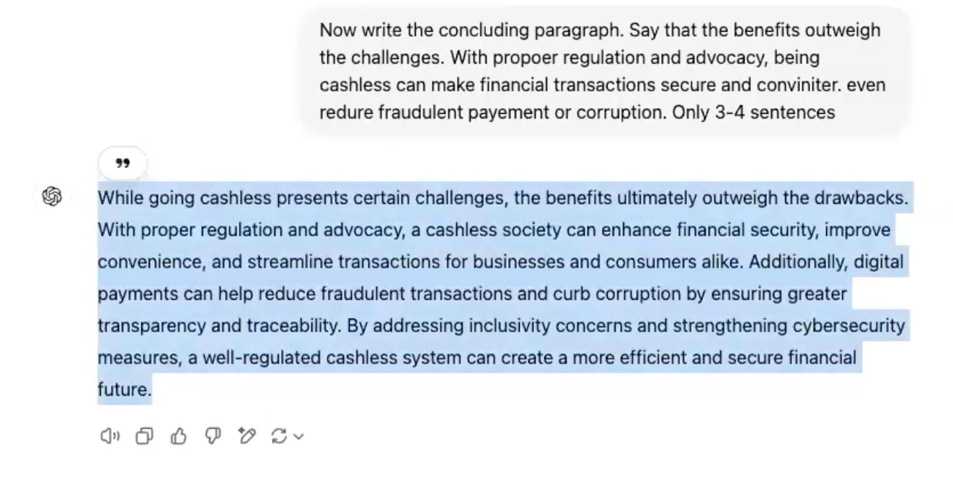

Fig. 5

In addition to the affordances observed during her writing process, Participant B highlighted how GenAI supports *self-assessment* in her academic writing. She explained, *“I’ll ask it to explain my writing in a simple way. If the explanation aligns with what I intended to say, then I know my writing is clear.”* She added, *“Sometimes I ask GenAI to explain it by asking what is the core idea of the paragraph?”*.

She also used GenAI for *writing feedback*, stating, *“Another way I use it is for getting feedback on my daily academic writing.”* [**Provide Feedback**].

Additionally, Participant B mentioned a different GenAI tool, Ludwig, which she found particularly useful for improving sentence structure. She explained, *“With Ludwig, it’s more about rearranging sentences to make them clearer.”* [**Enhance Clarity and Tone**].

**Packing:**

Participant B’s experience illustrates how GenAI tools support her writing through key affordances. She used GenAI to summarise background information, to guide structured writing, and to refine vocabulary, grammar, and cohesion. She iteratively interacted with GenAI to expand, rephrase, and polish her drafts, integrating its suggestions into her writing while maintaining her own voice.

Beyond the writing session, Participant B leveraged GenAI for self-assessment, asking it to simplify her writing to ensure clarity. She also sought writing feedback for her academic work and used another tool, Ludwig, for sentence restructuring. These affordances not only streamlined her writing process but also enhanced her confidence and precision in academic writing.